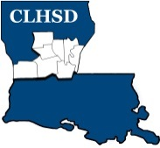
Central Louisiana Human Services District
Board Meeting Agenda
February 4, 2021

- Call to Order/Quorum
- Prayer/Pledge

- Read and Approve March 2021 Meeting Agenda
- Solicit Public Comment Requests

- Approval of Minutes

  - February 2021 Board Meeting Minutes
  - February 24, 2021 – Special Meeting Minutes

- District Reports

  - Financial Report- (Vote) H1

  - ED Monthly Report H2

- Board Business
  - Executive Session

  - Open meeting

- Questions/Comments as Solicited

- Next Month
- Policy Reviews – Executive Limits
- II.H. Compensation and Benefits – Rebecca Craig
- II.K. Community Relationships – Rebecca Craig
- Board Development/Training Save Cenla – Applied Suicide Intervention – Angie and Andy Dixon and the Extra Mile
- Tier 2.1 – Covering Calendar Year 2019 due by May 15th
- Annually Ethics training for the current year to be completed by the May meeting

- Announcements
Next meeting – April 1, 2021

- Adjourn (Vote)

